**A PROJECT REPORT**

**on**

**Dashabhuja**

**Submitted to**

**KIIT Deemed to be University**

**In Partial Fulfilment of the Requirement for the Award of**

**BACHELOR’S DEGREE IN**

**Computer Science and Engineering**

**BY**

|  |  |
| --- | --- |
| **Siddhartha Mukherjee** | 21052365 |
| **Rishav Das** | 21052347 |
| **Preenon Saha** | 21052342 |
| **Sourin Mukherjee** | 2105833 |
| **Dipankar Khanra** | 2105963 |

**UNDER THE GUIDANCE OF**

**Prof. (Dr.) Prachet Bhuyan**



**SCHOOL OF COMPUTER SCIENCE AND ENGINEERING**

**KALINGA INSTITUTE OF INDUSTRIAL TECHNOLOGY**

**BHUBANESWAR, ODISHA -751024**

**November, 2024**

A PROJECT REPORT

on

Dashabhuja

Submitted to

KIIT Deemed to be University

In Partial Fulfilment of the Requirement for the Award of

BACHELOR’S DEGREE IN

Computer Science and Engineering

BY

|  |  |
| --- | --- |
| Siddhartha Mukherjee | 21052365 |
| Rishav Das | 21052347 |
| Preenon Saha | 21052342 |
| Sourin Mukherjee | 2105833 |
| Dipankar Khanra | 2105963 |

UNDER THE GUIDANCE OF

Prof. (Dr.) Prachet Bhuyan



SCHOOL OF COMPUTER SCIENCE AND ENGINEERING

KALINGA INSTITUTE OF INDUSTRIAL TECHNOLOGY

BHUBANESWAR, ODISHA -751024

November, 2024

KIIT Deemed to be University

School of Computer Engineering

Bhubaneswar, 7501024



CERTIFICATE

This is to certify that the project entitled

Dashabhuja

submitted by

|  |  |
| --- | --- |
| Siddhartha Mukherjee | 21052365 |
| Rishav Das | 21052347 |
| Preenon Saha | 21052342 |
| Sourin Mukherjee | 2105833 |
| Dipankar Khanra | 2105963 |

is a record of bonafide work carried out by them, in the partial fulfilment of the requirement for the award of Degree of Bachelor of Engineering (Computer Science & Engineering) at KIIT Deemed to be university, Bhubaneswar. This work is done during year 2024, under our guidance.

Date: 13/11/2024

(Guide Name)

Prof. (Dr.) Prachet Bhuyan

**Acknowledgements**

We are profoundly grateful to **Prof. (Dr.) Prachet Bhuyan** of **KIIT Deemed to be University** for his expert guidance and continuous encouragement throughout to see that this project rights its target since its commencement to its completion.

Siddhartha Mukherjee

Rishav Das

Preenon Saha

Sourin Mukherjee

Dipankar Khanra

**ABSTRACT**

Dashabhuja is a comprehensive mobile application developed to empower and protect women through a suite of innovative features. The app is designed to address the distinct challenges faced by women, particularly in rural areas, where they often encounter barriers to personal safety, economic opportunities, and community support. At the core of Dashabhuja is a focus on women's safety and security. The app's integrated Emergency SOS feature mobilizes immediate assistance in critical situations, providing users with a vital lifeline. To further support women, Dashabhuja offers a secure community forum for anonymous crime reporting and peer-to-peer support. Beyond safety and security, the app empowers women through a range of personal development tools. Leveraging AI-generated guidance, Dashabhuja's interactive Yoga training module promotes physical and mental well-being. The app also facilitates the connection and collaboration of women-owned businesses, enabling them to showcase their products and reach new customers.

Through this holistic approach that addresses women's safety, economic opportunities, and personal growth, Dashabhuja fosters a stronger, more inclusive environment. By empowering women to take control of their well-being, the project aims to create a transformative impact, enabling them to thrive and reach their full potential.

**Keywords:**

Dashabhuja, Women Empowerment, SOS Feature, Geolocation Services, Yoga Training, React-Native, NodeJS, Real-Time Location Sharing, Rural E-Commerce, Safety Alerts

|  |  |  |  |  |
| --- | --- | --- | --- | --- |
| 1 | Introduction | | | 8 |
| 2 | Basic Concepts/ Literature Review | | | 9 |
|  | 2.1 | React Native | | 9 |
|  | 2.2 | MongoDB | | 9 |
|  | 2.3 | Node JS and Express JS | | 10 |
|  | 2.4 | Mapbox | | 10 |
|  | 2.5 | Cloudinary | | 10 |
|  | 2.6 | React JS | | 10 |
|  | 2.7 | AWS EC2 | | 11 |
|  | 2.8 | OpenCV | | 11 |
|  | 2.9 | WebRTC | | 11 |
| 3 | Problem Statement | | | 12 |
|  | 3.1 | Project Planning | | 12 |
|  | 3.2 | Project Analysis (SRS) | | 16 |
|  | 3.3 | System Design | | 18 |
|  |  | 3.3.1 | Design Constraints | 18 |
|  |  | 3.3.2 | System Architecture (UML) | 19 |
| 4 | Implementation | | | 24 |
|  | 4.1 | Methodology | | 24 |
|  | 4.2 | Testing Plan | | 25 |
|  | 4.3 | Screenshots | | 26 |
| 5 | Standard Adopted | | | 29 |
|  | 5.1 | Design Standards | | 29 |
|  | 5.2 | Coding Standards | | 29 |
|  | 5.3 | Testing Standards | | 30 |
| 6 | Conclusion and Future Scope | | | 31 |
|  | 6.1 | Conclusion | | 31 |
|  | 6.2 | Future Scope | | 31 |
| References | | | | 32 |
| Individual Contribution | | | | 33 |
| Plagiarism Report | | | | 43 |

Contents

List of Figures

|  |  |  |
| --- | --- | --- |
| **Fig No.** | **Figure Name** | **Page No.** |
| 3.1 | UML Use Case Diagram Case -1 | 21 |
| 3.2 | UML Use Case Diagram Case – 2 | 22 |
| 3.3 | UML Sequence Diagram | 23 |
| 4.1 | Splash Screen UI Screenshot | 26 |
| 4.2 | Home Screen UI Screenshot | 26 |
| 4.3 | Incident Reporting UI Screenshot | 26 |
| 4.4 | AI Based Yoga Trainer UI Screenshot (App) | 26 |
| 4.5 | Share Footprint UI Screenshot | 27 |
| 4.6 | Footprint View UI Screenshot (Browser) | 27 |
| 4.7 | Ecommerce Product Listing UI Screenshot | 27 |
| 4.8 | Ecommerce Address Input Form UI Screenshot | 27 |
| 4.9 | Yoga ML Model AI Screenshot (Browser) | 28 |

Chapter-1

Introduction

Dashabhuja is a multifaceted mobile application designed to uplift and empower women by providing solutions to the various challenges they face in the social and personal spheres. In many communities, women often lack access to the resources and support systems necessary for personal safety, community connection, and overall well-being. Dashabhuja aims to address these pressing issues through a comprehensive suite of features that prioritize women's security, foster a supportive community, and promote personal growth.

At the core of the Dashabhuja project is a focus on enhancing women's personal safety and security. The app integrates a real-time SOS feature that allows users to instantly alert emergency contacts and share their location in critical situations, providing a vital lifeline when it is needed most. Additionally, Dashabhuja offers a safe and anonymous community forum where users can report incidents, seek guidance on personal matters, and connect with others for mutual support. By utilizing sentiment analysis, the app helps prevent abusive language and creates a respectful, nurturing environment for all.

Beyond personal safety, Dashabhuja also empowers women through innovative technological solutions. The app harnesses the power of artificial intelligence to automatically generate engaging and detailed product descriptions, simplifying the process of setting up online listings for women-owned businesses and artisans. This feature helps to expand economic opportunities for women, enabling them to reach a broader customer base and increase their financial independence.

Complementing the economic empowerment initiatives, Dashabhuja also includes a Yoga training module powered by computer vision and machine learning. This feature provides women with guidance on fundamental self-defence techniques, boosting their confidence and physical security. By integrating this personal development component, the app aims to foster a holistic sense of well-being and self-reliance among its users.

Through this multifaceted approach, Dashabhuja strives to create a more inclusive and supportive environment for women, addressing their unique needs and empowering them to thrive. By prioritizing personal safety, community connection, and personal growth, the project seeks to contribute meaningfully to the economic and social empowerment of women, ensuring they have access to the tools and resources they need to build a brighter future.

Chapter-2

Basic Concepts

This section serves as a foundational pillar, encompassing the fundamental concepts and essential knowledge that are imperative for a comprehensive understanding of the project. It delves into the intricate details of the related tools and techniques employed throughout the development process, shedding light on their significance and the pivotal roles they play in shaping the final outcome of the project.

* 1. **React Native**:

React Native serves as a versatile framework for building cross-platform mobile applications, utilizing JavaScript and React to enable a cohesive experience on both Android and iOS devices. For the **Dashabhuja** app, we leveraged React Native to create a dynamic, user-friendly interface that aligns with the unique needs of rural women. React Native’s component-based structure allowed us to efficiently develop features such as real-time geolocation for nearby buyer connections, AI-generated product descriptions, and an integrated SOS feature for emergency assistance. By using React Native, we ensured Dashabhuja remains lightweight, responsive, and accessible, providing a seamless experience across devices and fostering a sense of ease and inclusivity for all users.

* 1. **MongoDB**:

MongoDB, a powerful NoSQL database, is integral to the backend infrastructure of **Dashabhuja**, enabling efficient handling of diverse data types and ensuring scalability as user numbers grow. For this application, MongoDB’s document-oriented structure allows seamless storage of user profiles, product listings, community forum discussions, and anonymous reports, all in a flexible JSON-like format. This flexibility supports complex relationships between data entries, such as linking users to products or tracking real-time updates for nearby buyers and sellers. MongoDB’s robust querying capabilities also facilitate quick retrieval of information, whether for geolocation services, SOS feature responses, or personalized community content, making it an ideal database solution for an app that prioritizes both performance and dynamic data management.

* 1. **Node.js and Express.js**:

Node.js and Express.js form the backbone of the **Dashabhuja** app’s server-side infrastructure, providing a powerful and efficient environment for handling requests and ensuring smooth data exchange between the client and database. Node.js, with its event-driven, non-blocking architecture, allows the app to manage multiple user requests simultaneously, which is essential for real-time features like geolocation tracking for nearby buyers, emergency SOS alerts, and community forum interactions.

Express.js complements Node.js by simplifying the creation of RESTful APIs, enabling a clean, organized routing system that seamlessly handles requests for functionalities such as AI-generated product descriptions, user authentication, and anonymous reporting.

* 1. **Mapbox:**

Mapbox is a key tool in **Dashabhuja**, providing precise geolocation and interactive mapping features that enhance the app’s functionality and usability. By integrating Mapbox, Dashabhuja allows users to locate nearby buyers, sellers, and resources like donation centres or support hubs, fostering local connections for product sales and community support. The map interface guides users with clear navigation and real-time positioning, which is particularly valuable for emergency responses in the app’s SOS feature, enabling swift location sharing with emergency contacts.

* 1. **Cloudinary**:

Cloudinary is an essential component in **Dashabhuja**, handling the storage, management, and delivery of images uploaded by users with high efficiency. For an app focused on connecting rural women with local buyers, Cloudinary allows seamless product image uploads, ensuring that images are optimized for quality and loading speed. This image optimization enhances the user experience, as potential buyers can quickly view clear, attractive photos of products, while sellers benefit from easy image handling without worrying about file size or formatting.

* 1. **React.js**:

React.js plays a pivotal role in **Dashabhuja**'s web-based interface, providing a responsive and interactive user experience. With its component-based structure, React.js enables efficient development and maintenance of Dashabhuja’s various features, such as the product listing interface, community forum, and support sections. React’s virtual DOM enhances the app's speed, allowing users to navigate seamlessly through different sections without delays. This framework ensures a dynamic and user-friendly web experience, making Dashabhuja easily accessible and intuitive for all users, including those in rural areas with limited technical familiarity.

**2.7 AWS EC2:**

AWS powers **Dashabhuja** by providing scalable and reliable cloud infrastructure. With its virtual servers (EC2), AWS ensures fast response times and high availability for features like geolocation, SOS alerts, and product listings. The platform’s easy-to-use tools enable efficient deployment and management, while its scalability supports growing data as more users join. Additionally, AWS’s strong security measures ensure the protection of user data, making it an ideal choice for hosting Dashabhuja’s backend services.

**2.8 OpenCV:**

OpenCV is integrated into **Dashabhuja** to enhance the Yoga training feature, offering real-time feedback on martial arts techniques using computer vision. By leveraging OpenCV, the app can analyze users' movements, providing guidance and corrections to ensure proper execution of Yoga practices. This integration helps users, especially women, learn and improve their Yoga skills effectively. OpenCV's powerful image processing capabilities also enable real-time tracking and gesture recognition, making the training interactive and personalized, and ensuring a more immersive and productive experience for users.

**2.9 Streamlit:**

Streamlit is used in **Dashabhuja** to quickly develop and deploy interactive web-based data applications, particularly for features that require real-time data visualization and analysis. It allows for the development of simple, yet powerful interfaces where users can track their progress, view instructional content. The app can integrate visualizations such as performance metrics or step-by-step guides for yoga poses, providing real-time feedback and tracking. Streamlit’s quick deployment ensures that these interactive tools can be updated and refined easily, creating an engaging and motivating experience for users as they improve their yoga skills.

Chapter-3

Problem Statement

In today's rapidly evolving society, women continue to face significant challenges regarding personal safety, community support, and access to empowerment resources. The lack of immediate assistance during emergency situations poses a serious threat to women's safety, particularly in areas with limited security infrastructure. When faced with threatening situations, women often struggle to quickly alert their trusted contacts or nearby help, leaving them vulnerable during critical moments. Furthermore, the absence of a secure and anonymous platform for reporting incidents has led to many crimes going unreported, perpetuating a cycle of silence and vulnerability. Women frequently hesitate to report harassment or safety concerns due to fear of social stigma or potential repercussions, highlighting the urgent need for confidential reporting mechanisms. The isolation experienced by many women, especially in rural areas, hampers their personal growth and community connection. Without access to proper wellness guidance and community support systems, women miss out on opportunities for physical and mental well-being enhancement. The lack of platforms for sharing experiences and success stories creates barriers to mutual support and empowerment. Additionally, women entrepreneurs, particularly those running small-scale businesses, face challenges in reaching potential customers and growing their ventures. The limited access to user-friendly digital platforms restricts their ability to showcase their products and achieve financial independence. These interconnected challenges highlight the need for a comprehensive solution that addresses safety concerns, promotes community building, and supports personal development, while ensuring accessibility and user privacy. The absence of such an integrated platform continues to impact women's overall well-being and their ability to participate fully in society.

**3.1 Project Planning**

1. **Requirements Gathering:**

The research revealed that while many women faced safety issues, they often hesitated to report incidents due to privacy concerns and social stigma. Additionally, discussions with women entrepreneurs highlighted the need for platforms that could support their economic independence. Technical requirements were determined through consultations with security experts, wellness professionals, and technology specialists to ensure the implementation of robust safety features and user-friendly interfaces. The findings emphasized the importance of an integrated approach that combines safety features with community support and personal development tools. This thorough requirement gathering process helped shape Dashabhuja's key features, ensuring they effectively address the real needs of women while maintaining user privacy and data security.

**Key objectives of the project include:**

1. **Safety and Security Enhancement**

The primary objective of Dashabhuja is to create a robust safety network for women through its Emergency SOS and Live Footprints features. The project aims to provide immediate assistance during emergencies by automatically alerting trusted contacts, sharing real-time location data, and notifying nearby app users within a 10km radius. This comprehensive approach ensures that help is readily available when needed most.

1. **Crime Prevention and Reporting**

Through its anonymous crime reporting feature, the project aims to create a safer environment by enabling women to report incidents without fear of repercussion. This objective addresses the critical need for safe and confidential reporting mechanisms, encouraging more women to speak up against crimes and contributing to community safety.

1. **Health and Wellness Promotion**

The project endeavours to promote physical and mental well-being through its AI-powered Yoga training module. By providing real-time feedback on yoga postures and techniques, Dashabhuja aims to make quality wellness guidance accessible to women, helping them maintain good health and build confidence through proper exercise techniques.

1. **Community Building and Support**

Dashabhuja seeks to foster a supportive and empowering community where women can share their experiences, success stories, and challenges. By providing a platform for meaningful connections and mutual support, the project aims to break down isolation barriers and create a network where women can find encouragement, guidance, and inspiration from others who have faced similar experiences.

**5. Economic Empowerment**

Dashabhuja aims to support women's economic independence by providing a platform for women entrepreneurs to showcase and sell their products. This objective helps bridge the gap between women-owned businesses and potential customers, contributing to their financial growth and independence.

1. **Technology Feasibility Assessment:**
2. **Mobile Application Development:**

**React Native:** Utilizing React Native for mobile app development provides cross-platform compatibility with native-like performance making it a suitable choice for our project.

1. **Backend Development:**

**Node.js:** Node.js is a lightweight and efficient runtime environment for server-side applications. It’s well-suited for building scalable and high-performance backend services, making it a viable option for the backend of our mobile application.

**Express.js:** Express.js is a minimalist web framework for Node.js, providing a robust set of features for building RESTful APIs and handling HTTP requests. It can be used to develop the backend API endpoints required for your application.

1. **Database:**

**MongoDB:** MongoDB is a NoSQL database ideal for handling large and varied datasets, such as user profiles, product listings, and community posts in Dashabhuja. Its document-oriented structure allows flexible data management; while indexing and querying enhance quick data access. MongoDB’s scalability and seamless integration with Node.js make it well-suited to support Dashabhuja's growing needs for an intuitive and responsive platform.

1. **AI Services:**

**Google Gemini 1.5 Flash**: Google Gemini 1.5 Flash API is suitable for implementing AI-based product description for the e-commerce product upload feature. Its integration with Google Cloud Platform ensures reliable performance and scalability for our application’s image recognition needs.

1. **Feature Specification and Acceptance Criteria:**
2. **SOS Emergency Feature:**

**Feature Specification:**

* Users can trigger an immediate SOS alert system that notifies emergency contacts with real-time location data during crisis situations.
* Integration with GPS for accurate location tracking.
* Automatic notification system for emergency contacts by SMS or and direct call.

**Acceptance Criteria:**

* + - Users can successfully trigger SOS alerts with a single action.
    - Emergency contacts receive instant notifications with accurate location data.
    - System provides confirmation of successful alert transmission.
    - Real-time location updates continue until the emergency is resolved.

1. **Map Integration for Location-Based Services**

**Feature Specification:**

* Integration of Mapbox for comprehensive location-based services
* Real-time tracking and navigation capabilities
* Visualization of nearby users and emergency services

**Acceptance Criteria:**

* Accurate display of user location and nearby services.
* Seamless navigation functionality within the app.
* Real-time updates of location-based data.
* Efficient routing to emergency services and safe locations.

1. **Community Engagement Platform**

**Feature Specification:**

* Secure and anonymous forum for incident reporting.
* Platform for sharing experiences and seeking advice.
* Blog post creation and sharing capabilities.
* Community support network building.

**Acceptance Criteria:**

* Users can successfully post and share content anonymously.
* Effective moderation system for content management.
* Smooth navigation through blog posts and community content.
* Secure user authentication for sensitive information.

1. **Yoga Training Module**

**Feature Specification:**

* AI-powered yoga training system using OpenCV and MediaPipe
* Real-time posture analysis and feedback
* Visual guidance for proper technique
* Progress tracking capabilities

**Acceptance Criteria:**

* Accurate detection and analysis of user poses
* Real-time feedback on pose corrections
* Smooth video processing and minimal latency
* Clear and actionable guidance for improvement

1. **Product Listing and E-Commerce**

**Feature Specification:**

* User-friendly interface for product listing
* AI-assisted product description generation
* Location-based product search and filtering
* Secure transaction system

**Acceptance Criteria:**

* Successful product listing with images and descriptions
* Accurate AI-generated product descriptions
* Effective search and filter functionality
* Smooth transaction processing
  1. **Project Analysis**

**1. Feature Analysis**

**SOS Emergency Feature**

* **Feature Importance:** Critical
* **Complexity:** High
* **Dependencies:**
  + Location services integration
  + Real-time notification system
  + Emergency contact management
  + Database for trusted contacts
* **Priority:** HIGH

**Map Integration for Location-Based Services**

* **Feature Importance:** High
* **Complexity:** High
* **Dependencies:**
  + Mapbox API integration
  + Real-time location tracking
  + Geospatial database management
* **Priority:** HIGH

**Community Forum for Queries and Support**

* **Feature Importance:** High
* **Complexity:** Moderate
* **Dependencies:**
  + User authentication system
  + Content moderation tools
  + Anonymous posting mechanism
  + Real-time notification system
* **Priority:** High

**Product Listing and Selling**

* **Feature Importance:** Medium
* **Complexity:** Moderate
* **Dependencies:**
  + Product database
  + AI description generator
  + Search and filter system
  + Payment gateway integration
* **Priority:** Medium

**2. Technical Analysis**

**Core Infrastructure**

* **Mobile Application Development**
  + Framework: React Native
  + Purpose: Cross-platform compatibility (iOS and Android)
  + Focus: Optimized user experience and performance
* **Backend Architecture**
  + Database: MongoDB for flexible data storage
  + Server: Node.js with Express.js
  + Features: RESTful API endpoints, real-time data processing

**Advanced Technology Integration**

* **AI and Computer Vision**
  + Technologies: OpenCV, MediaPipe
  + Applications:
    - Real-time Yoga pose analysis
    - Automated product description generation
* **Location Services**
  + Platform: Mapbox
  + Features:
    - Real-time location tracking
    - Geofencing for local services
    - Navigation system integration

**3. Risk Analysis**

**Security Risks**

* User data privacy protection
* Location data security
* Emergency contact information protection
* Secure communication channels
* Mitigation:
  + End-to-end encryption
  + Secure access protocols
  + Regular security audits

**Technical Risks**

* Third-party service dependencies
  + Impact: Service interruptions
  + Mitigation: Backup services and fallback mechanisms
* Real-time feature performance
  + Impact: Response time for critical features
  + Mitigation: Optimization and load balancing

**3.3 System Design:**

## **3.3.1 Design Constraints**

**Security**

* Robust authentication and authorization mechanisms
* Secure storage of sensitive user data
* Protected API endpoints

**Performance**

* Fast response times for critical features (especially SOS)
* Optimized app performance on low-end devices
* Efficient operation in limited network conditions
* Minimal latency for real-time features
* Optimized battery consumption

**Scalability**

* Support for growing user base
* Handling concurrent emergency requests
* Efficient data storage and retrieval
* Load balancing for high traffic
* Horizontal scaling capabilities

**3.3.2 System Architecture**

**Technology: React Native**

* Cross-platform mobile development
* Native-like user experience
* Reusable components
* Optimized performance
* Platform-specific adaptations

**Database Systems**

**Technology: MongoDB**

* Real-time data management
* Flexible document structure
* Efficient querying
* Geospatial indexing
* Scalable data storage

**Backend Infrastructure**

**Technology: Node.js & Express**

* RESTful API development
* Business logic implementation
* Request handling and routing
* External API integration
* Middleware management

**AI and Computer Vision**

**Technology: OpenCV & MediaPipe**

* Real-time pose detection
* Image processing for products
* Computer vision algorithms
* Machine learning integration
* Performance optimization

**Location Services**

**Technology: Mapbox**

* Real-time location tracking
* Geofencing implementation
* Emergency service mapping
* Route optimization
* Distance calculations

**Media Storage**

**Technology: Cloudinary**

* Secure image storage
* Automatic optimization
* CDN integration
* Image transformation
* Backup management

**Cloud Infrastructure**

**Technology: Amazon EC2**

* Scalable compute resources
* High availability
* Load balancing
* Auto-scaling capabilities
* Global deployment options

**3.3.3 System Integration**

The architecture implements a microservices-based approach where each component operates independently while maintaining seamless integration:

1. **Frontend Layer**
   * React Native interfaces with backend services
   * Handles user interactions and display logic
   * Manages local state and caching
2. **Data Layer**
   * MongoDB manages structured data
   * Cloudinary handles media storage
   * Implements data backup and recovery
3. **Service Layer**
   * Node.js processes business logic
   * Handles API requests
   * Manages external service integration
4. **Infrastructure Layer**
   * Amazon EC2 provides hosting environment
   * Ensures high availability
   * Manages scaling and performance

This integrated architecture ensures robust security, optimal performance, and scalability while maintaining a seamless user experience across all app features.

* + 1. **UML Use Case Diagrams:**

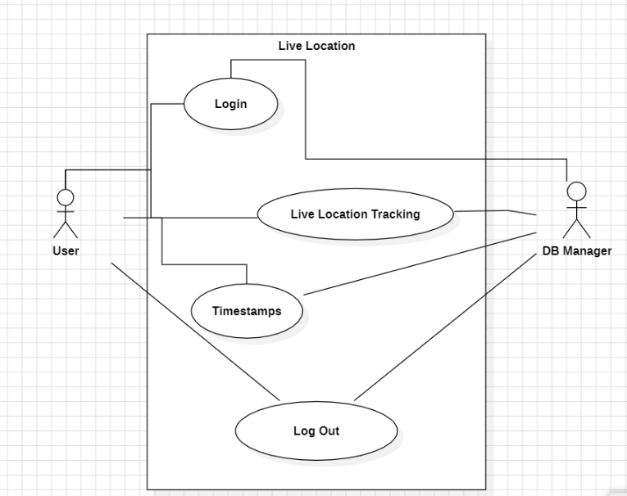

**Fig:3.1 UML Use Case Diagram Case-1**

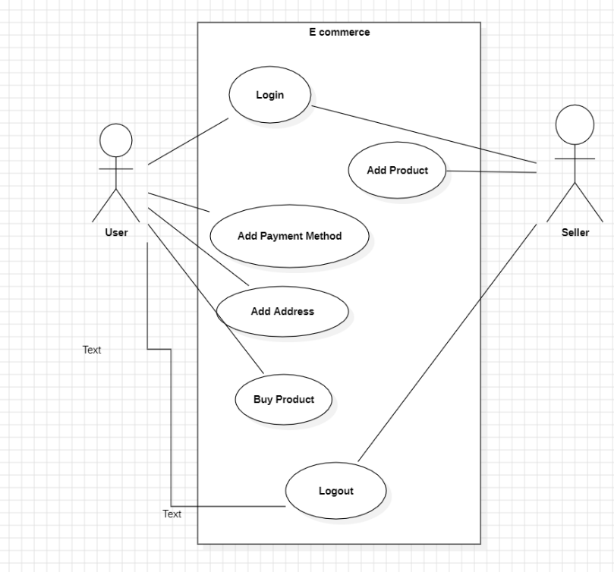

**Fig:3.2 UML Use Case Diagram Case-2**

**3.3.5 UML Sequence Diagram**

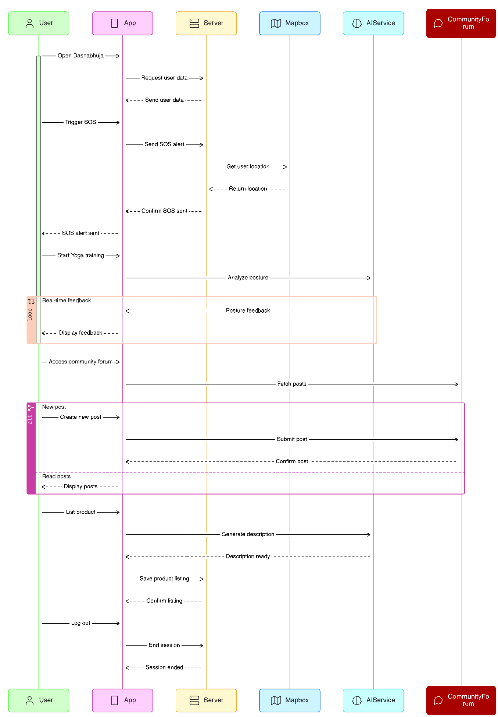

**Fig:3.3 UML Sequence Diagram**

Chapter 4

Implementation

For the implementation of the project, the following methodology was adopted:

**4.1 Methodology:**

* **Agile Development**: The project adopted an agile development methodology, utilizing iterative sprints to ensure adaptability and continuous improvement. This approach enabled rapid response to changes in requirements and provided opportunities for regular feedback, helping the team to refine features based on real user needs.
* **Feature Prioritization**: Core functionalities, such as product listing, location-based services, and user safety features, were prioritized based on user needs and feasibility. Secondary features, including community forums and Yoga guidance, were scheduled for later iterations to balance complexity and project goals.
* **Technology Stack Selection**: React Native was chosen for cross-platform development, enabling efficient Android and iOS compatibility. MongoDB provided a scalable database solution, while Node.js and Express handled backend services. Firebase was selected for secure authentication, and Mapbox for accurate geolocation services.
* **Collaborative Development**: The team used GitHub for version control, promoting collaborative coding practices, issue tracking, and code review through pull requests. Regular meetings facilitated coordination and addressed any development challenges or adjustments.
* **Iterative Development and Feedback Loop**: Each sprint concluded with a demo session to gather stakeholder feedback, ensuring that feature development remained aligned with user expectations and project goals. This iterative approach allowed ongoing refinement, keeping the project agile and responsive to new insights and requirements.

**4.2 Testing Plan**

After the completion of the project implementation, the following testing and verification plan was executed:

* + **Unit Testing:** Unit tests were written for individual components and functionalities of the application, ensuring that each part of the system behaved as expected.
  + **Integration Testing:** Integration tests were conducted to verify the interactions between different components and services, ensuring seamless communication and data flow.
  + **Validation Testing:** Various validation tests, including functional, usability testing was carried out, so that the application's features and functionalities were rigorously assessed to ensure they met the specified requirements and provided a seamless user experience.
  + **Performance Testing:** Performance tests were conducted to assess the responsiveness and scalability of the application under different loads and usage scenarios. This ensured that the application could handle concurrent user activity and maintain acceptable performance levels.

**Production Build Test Cases and Issue Resolution Log**

|  |  |  |  |  |
| --- | --- | --- | --- | --- |
| **Test ID** | **Test Case Title** | **Test Condition** | **System Behaviour** | **Expected Result** |
| T01 | Python Version Issue | Running the application in EC2 | AI model was unable to install the dependencies because of mismatching Python versions. | AI Model should automatically install the dependencies without any errors. |
| T02 | Activity Indicator Visibility Issue | Product page load | Activity indicator not visible | Activity indicator added and visible |
| T03 | Font colour Issue in Dark Mode UI | Dark mode enabled in address input page | Text colour becomes invisible during dark mode | Font colour adjusted for visibility in dark mode |
| T04 | AI Model Crash | Multiple users access AI Model at the same time | The EC2 instance crashed when multiple users access the model. | The AI Model and the EC2 instance should run without fail or crash. |
|  |  |  |  |  |

* 1. **Screenshots of Implementation:**

|  |  |
| --- | --- |
|  |  |
| **Fig 4.1- Splash Screen UI** | **Fig 4.2- Home Screen UI** |
|  |  |
| **Fig 4.3- Incident Reporting UI** | **Fig 4.4- AI Based Yoga Trainer** |
|  |  |
| **Fig 4.5- Sharing Footprint UI** | **Fig 4.6- Footprint View UI (Browser)** |
| **Fig 4.7 Ecommerce Listing UI** | **Fig 4.8- Ecommerce Address UI** |
|  |  |

|  |
| --- |
|  |
| **Fig 4.9- Yoga AI ML Model UI** |

Chapter 5

Standards Adopted

**5.1 Design Standards:**

In adherence to established design standards, our project followed a systematic approach to architecting the software system. We employed the following recommended practices:

* **Utilization of UML Diagrams**: Unified Modelling Language (UML) diagrams were extensively used to visualize and document the system architecture, including use case diagrams, class diagrams. These diagrams provided a clear understanding of the system's structure, behaviour, and interactions.
* **Modular Design Approach**: The system was designed using a modular approach, with complex components broken down into smaller, manageable modules. This modular design facilitated reusability, maintainability, and scalability, allowing for easier management of the codebase.
* **Scalability Considerations**: During the design phase, we meticulously assessed scalability requirements, ensuring that the system was structured to seamlessly accommodate future expansion in user base, data volume, and functionality. We implemented scalable architecture patterns, including utilization of cloud computing services were deemed appropriate, to fortify the system's ability to grow and evolve.

**5.2 Coding Standards:**

The project adhered to established coding standards to ensure consistency, readability, and maintainability of the codebase. Key coding standards followed include:

* **Meaningful Naming Conventions**: Descriptive and meaningful names were used for variables, functions, classes, and other identifiers, following consistent naming conventions such as camelCase.
* **Structured Code Organization**: Code was organized into logical blocks and modules, with clear separation of concerns were employed to promote code modularity and maintainability.
* **Clear Code Readability**: Code was written with clarity and conciseness in mind, avoiding overly complex or convoluted logic. Comments and documentation were utilized to explain the purpose of code blocks, algorithms, and complex operations.
* **Consistent Indentation and Formatting**: Consistent indentation and formatting styles were applied throughout the codebase to enhance readability. Industry-standard formatting guidelines were followed, and code linters were utilized to enforce consistent coding styles.
* **Robust Error Handling**: Robust error handling mechanisms were implemented to gracefully handle exceptions, errors, and edge cases. Appropriate error codes, logging, and exception handling techniques were employed to aid in troubleshooting and debugging.

**5.3 Testing Standards:**

The project followed established testing standards to ensure the reliability, functionality, and quality of the software product. Key testing standards observed include:

* **Documentation as per IEEE 829**: Test documentation was prepared in accordance with IEEE 829 standard, outlining the format and content of various test documents, including test plans, test cases, and test reports.
* **Comprehensive Test Coverage**: Comprehensive test coverage was achieved through a combination of unit tests, integration tests, system tests, and acceptance tests.

Chapter 6

Conclusion and Future Scope

**6.1 Conclusion:**

In conclusion, the Dashabhuja project has successfully addressed the unique challenges faced by rural women in promoting and selling their products by developing an empowering mobile application. By integrating a secure e-commerce platform, location-based connections between buyers and sellers, and a supportive community forum, Dashabhuja has created a user-friendly and impactful tool for economic empowerment. Additionally, safety features such as the SOS function and AI-assisted product descriptions enhance both the security and convenience of the platform. This project provides rural women with a seamless digital marketplace and access to critical support resources, fostering growth, security, and community within the digital economy

**7.2 Future Scope:**

While Dashabhuja has successfully addressed critical challenges in empowering rural women through e-commerce and support resources, there are numerous opportunities for future enhancement and expansion:

* **Advanced AI Product Recommendations:** Expand AI capabilities to provide intelligent product recommendations based on user preferences and market trends. This enhancement would make the shopping experience even more tailored and assist sellers in showcasing products more effectively.
* **Social Networking and Community Expansion:** Introduce a more interactive community by adding features such as user profiles, in-app messaging, and forums. By expanding social networking capabilities, the app can foster stronger connections and support networks among women users.
* **Integration of Financial Services:** Provide financial support features, such as microloans or payment solutions, to empower sellers to scale their businesses. This can enable women entrepreneurs to reinvest in their products and grow their economic independence.

By pursuing these future developments, Dashabhuja can evolve into a more comprehensive tool for economic and social empowerment, transforming the landscape for rural women entrepreneurs and enhancing the app’s long-term impact.

**References:**

The following references were taken into considerations while preparing the project:

1. React Native Documentation:

<https://reactnative.dev/docs/getting-started>

1. Node JS Documentation:

<https://nodejs.org/docs/latest/api/>

1. AWS EC2 Documentation:

<https://docs.aws.amazon.com/ec2/>

1. React JS Documentation:

<https://react.dev/learn>

1. Google Gemini Documentation

<https://ai.google.dev/tutorials/get_started_node>

These references provided valuable information and guidance during the development of the project.

# **INDIVIDUAL CONTRIBUTION REPORT**

**Dashabhuja**

SIDDHARTHA MUKHERJEE

Roll- 21052365

**Abstract:** As a key contributor to the Dashabhuja women's empowerment project, I played a central role in architecting and implementing this comprehensive mobile application designed to enhance women's safety and empowerment. The project integrates critical features such as Emergency SOS alerts, live location tracking, and AI-powered modules, creating a robust platform for women's security, community support and wellness. My contributions encompassed the entire technical stack, from backend development to cloud deployment, ensuring the delivery of a scalable and efficient solution that effectively addresses the pressing needs of women's safety in our society.

**Individual Technical Contributions and Findings:** My primary technical contribution cantered on developing the entire backend infrastructure of the application, where I implemented a robust server using Node.js and Express.js, carefully architecting the API endpoints to handle critical features such as emergency alerts and location tracking. The deployment phase presented unique challenges, particularly when hosting the application on Amazon EC2, where I configured Ubuntu servers to optimize performance and reliability. A significant technical challenge arose during the integration of the AI model, where server crashes occurred during multiple concurrent user access. The frontend development was equally crucial, where I took charge of designing and implementing the entire React Native application, ensuring seamless integration with backend services and implementing complex business logic for features like real-time emergency alerts and location sharing.

**Contribution to Project Report Preparation:** In the documentation phase of the project, I took a leadership role in defining the project's scope and requirements. My contributions included crafting a comprehensive problem statement that accurately captured the challenges faced by women in terms of safety and community support. Throughout the documentation process, I maintained meticulous records of our development progress, including screenshots and technical specifications that demonstrated the functionality and effectiveness of our solutions. This thorough documentation not only served as a valuable reference for the team but also helped ensure consistency and quality in our implementation.

**Individual Contributions for Project Presentation and Demonstration:** During the project presentation phase, I took the lead in showcasing our application's capabilities to stakeholders. My presentation focused on demonstrating the critical features of Dashabhuja, particularly emphasizing the emergency response system and location tracking capabilities. Through live demonstrations, I effectively illustrated how the application handles emergency situations, from triggering SOS alerts to notifying nearby users and sharing real-time location data with emergency contacts. I also presented the AI model's functionality, showcasing how it enhances the user experience while explaining the technical challenges we overcame in its implementation. This comprehensive demonstration helped stakeholders understand both the technical sophistication and practical impact of our solution.

|  |  |
| --- | --- |
| Full Signature of Supervisor: | Full signature of Student: |
|  |  |
| **. . . . . . . . . . . . . . . . . . . . . . . . .** | **. . . . . . . . . . . . . . . . . . . . .** |

# **INDIVIDUAL CONTRIBUTION REPORT**

**Dashabhuja**

RISHAV DAS

Roll- 21052347

**Abstract:** Dashabhuja is a mobile app designed to empower rural women by providing a secure platform to market and sell products, access safety resources, and build community support. Key features include location-based product listings, AI-driven product descriptions, community forums, and an emergency SOS function. The app leverages Firebase for real-time data, AI for image analysis, and a scalable backend to ensure a secure and seamless experience. Through a combination of e-commerce, safety, and community engagement, Dashabhuja promotes economic independence and personal empowerment for women in rural communities.

**Individual Contribution and Findings:** In the development of Dashabhuja, I played a central role in project planning, documentation, and research. My responsibilities included extensive research to identify the specific needs of rural women entrepreneurs and to tailor features that would provide the greatest empowerment and accessibility for them. I contributed significantly to the requirements gathering process, identifying essential app functionalities, and ensuring they aligned with our objectives of providing a safe, supportive, and resourceful platform. I created all necessary system design diagrams, including UML, sequence, and ER diagrams, which were essential in guiding the team through a clear architectural framework. Additionally, I authored the Software Requirements Specification (SRS) document, which detailed project requirements, constraints, and design expectations to provide a coherent roadmap for development.

**Individual Contribution to Project Report Preparation:** In the project report, I was responsible for writing key sections, including the project introduction (Chapter 1), which outlined the primary goals and objectives of Dashabhuja. I also documented the implementation phase (Chapter 4), covering the methodology, system architecture, testing procedures, and integration of core features. Additionally, I contributed to the chapter on standards and guidelines (Chapter 5), outlining the design, coding, and testing standards that maintained quality and consistency throughout development.

**Individual Contribution to Project Presentation and Demonstration:** During the project presentation and demonstration, I was instrumental in showcasing Dashabhuja’s features and user journey. I demonstrated how users can access the SOS feature, community forums, and AI-powered product descriptions, highlighting the app's unique focus on safety and empowerment for rural women. I presented these features with a focus on how they create a supportive ecosystem, ensuring the audience understood Dashabhuja’s impact. Through my contributions

in research, documentation, and demonstration, I helped shape Dashabhuja into a well-documented, user-centric platform designed to meet the specific needs of its audience and to support their economic and personal growth.

|  |  |
| --- | --- |
| Full Signature of Supervisor: | Full signature of Student: |
|  | WhatsApp Image 2024-11-13 at 15.45.22 |
| **. . . . . . . . . . . . . . . . . . . . . . . .** | **. . . . . . . . . . . . . . . . . . . . .** |

# **INDIVIDUAL CONTRIBUTION REPORT**

**Dashabhuja**

PREENON SAHA

Roll- 21052342

**Abstract:** Dashabhuja is a mobile application crafted to empower rural women by offering a safe and accessible platform for entrepreneurship, safety, and community building. The app integrates key features like location-based product listings, AI-generated product descriptions, community forums, and a one-tap emergency SOS function. Leveraging Firebase for real-time data management and AI for image analysis, Dashabhuja delivers a secure, efficient user experience supported by a scalable backend. By combining e-commerce capabilities, safety resources, and community engagement tools, Dashabhuja fosters economic independence, personal empowerment, and social support for women in rural areas.

**Individual Contribution and Findings:** In the development of Dashabhuja, my primary focus was on implementing a machine learning feature to predict the accuracy of yoga poses using real-time video analysis. I was responsible for gathering and preprocessing the data required for this feature, utilizing OpenCV and Mediapipe to enhance video analysis precision. My work involved creating a dataset of various yoga poses and refining it through extensive preprocessing to improve model accuracy and reliability in real-world settings. Through OpenCV and Mediapipe, I implemented key data processing techniques, such as pose detection and keypoint extraction, that laid the foundation for accurate pose prediction.

**Individual Contribution to Project Report Preparation:** In the project report, I documented the machine learning methodology in the implementation section (Chapter 4), detailing data collection, preprocessing, model selection, and performance evaluation. I also contributed to the technical appendix, where I provided in-depth explanations of the OpenCV and Mediapipe libraries, as well as their application in real-time pose accuracy prediction. Additionally, I collaborated on the chapter discussing standards (Chapter 5), contributing to guidelines for data handling, processing, and evaluation metrics to ensure accuracy and consistency in the machine learning component.

**Individual Contribution to Project Presentation and Demonstration:** During the project presentation and demonstration, I showcased the machine learning feature’s real-time yoga pose accuracy prediction. I explained the importance of data preprocessing and how OpenCV and Mediapipe supported accurate pose detection. By demonstrating this feature’s functionality, I highlighted how the Dashabhuja app provides a unique, engaging experience for rural women, enabling them to improve their skills in a safe and supportive environment. Through my

contributions to machine learning, data processing, and presentation, I helped integrate an innovative and empowering feature within Dashabhuja.

|  |  |
| --- | --- |
| Full Signature of Supervisor: | Full signature of Student: |
|  | 2023_09_28 12_52 AM Office Lens |
| **. . . . . . . . . . . . . . . . . . . . . . . . .** | **. . . . . . . . . . . . . . . . . . . . .** |

**INDIVIDUAL CONTRIBUTION REPORT:**

**Dashabhuja**

SOURIN MUKHERJEE

Roll- 2105833

**Abstract:** As a key contributor to the Dashabhuja women's empowerment project, I played a central role in architecting and implementing this comprehensive mobile application designed to enhance women's safety and empowerment. The project integrates critical features such as Emergency SOS alerts, live location tracking, and AI-powered modules, creating a robust platform for women's security, community support and wellness. My contributions encompassed the entire technical stack, from backend development to cloud deployment, ensuring the delivery of a scalable and efficient solution that effectively addresses the pressing needs of women's safety in our society.

**Individual contribution and findings:** I created a yoga pose detection interface for the Dashabhuja app using Streamlit, integrating machine learning and computer vision to enhance user experience. My contributions include developing the Machine Learning model and implementing Mediapipe for pose estimation, which enables accurate detection of yoga postures. I built a machine learning model in pkl format that predicts pose accuracy based on extracted body landmarks, leveraging Mediapipe’s pose module to capture these features. The app supports specific pose selection, displays images for each pose, and provides real-time accuracy feedback on a webcam feed. I also enhanced user interactivity by implementing WebRTC streaming for live pose detection and adding team branding elements in the sidebar, making the app both functional and visually appealing.

**Individual contribution to project report preparation:** For the project report preparation, I contributed significantly to the OpenCV and WebRTC section, providing context on the project's background and rationale. Additionally, I outlined the basic features of Dashabhuja Yoga AI in the corresponding section, highlighting its core functionalities and value proposition. My contributions aimed to provide readers with a comprehensive understanding of Machine Learning and Computer Vision, setting the stage for the subsequent chapters.

**Individual contribution for project presentation and demonstration:** During the project presentation phase, I took a valuable role in showcasing our Yoga application's capabilities to stakeholders. I crafted a compelling narrative that

effectively communicates Dashabhuja’s value proposition and key features to the audience. During the demonstration, I showcased the UI prototypes of our streamlit app, highlighting the intuitive navigation and interactive elements of the platform. Additionally, I addressed audience inquiries and asked them to try our yoga app with the functionality of Mediapipe by Google ensuring a comprehensive understanding of the application’s potential impact and future trajectory.

|  |  |
| --- | --- |
| Full Signature of Supervisor: | Full signature of Student: |
|  | WhatsApp Image 2024-11-13 at 19.03.29 |
| **. . . . . . . . . . . . . . . . . . . . . . . . .** | **. . . . . . . . . . . . . . . . . . . . .** |

**INDIVIDUAL CONTRIBUTION REPORT:**

**Dashabhuja**

DIPANKAR KHANRA

Roll- 2105963

**Abstract:** The Dashabhuja is a mobile app dedicated to empowering and protecting women, especially in rural areas, by addressing challenges in safety, economic empowerment, and community support. Key features include an Emergency SOS for instant help, an anonymous crime-reporting forum, and a peer-support network. Beyond safety, Dashabhuja offers AI-driven tools for personal growth, like interactive Yoga training for wellness and a platform for women-owned businesses to connect with customers. Through this comprehensive approach, Dashabhuja creates an inclusive space where women can enhance their security, promote their businesses, and support their personal well-being.

**Individual contribution and findings:** In the Dashabhuja project, my key contributions included designing the Software Requirements Specification (SRS) file and developing UML diagrams such as use case, class, and sequence diagrams to outline the app's architecture and workflows. These tasks were essential for defining functional and non-functional requirements, enabling a clear development road map. I focused on creating a user-cantered design that prioritized security and usability, particularly for the app’s safety and empowerment features. Through this process, I gained valuable insights into balancing technical demands with the sensitive needs of our target users..

**Individual contribution to project report preparation:** In preparing the project report for Dashabhuja, I contributed by structuring the document to clearly present the app’s objectives, features, and technical design. I compiled and refined information from the SRS file, UML diagrams, and other project artifacts, ensuring consistency and clarity. Additionally, I provided detailed explanations of key components, including the Emergency SOS feature, anonymous reporting, and AI-driven wellness tools, to highlight their significance in empowering women. My contributions helped create a cohesive report that effectively communicates the project’s purpose, technical elements, and social impact.

**Individual contribution for project presentation and demonstration:** For the project presentation and demonstration of Dashabhuja, I contributed by designing a clear and engaging PowerPoint presentation to highlight the app's core objectives, features, and functionality. I structured the presentation to emphasize key elements

like the Emergency SOS, anonymous reporting, and AI-based wellness modules, aligning each feature with the app's goal of empowering women. During the demonstration, I showcased the app’s user interface and key workflows, providing a live walk through to illustrate how users interact with each feature. My role was essential in ensuring that the presentation effectively communicated the app’s impact and usability to the audience.

|  |  |
| --- | --- |
| Full Signature of Supervisor: | Full signature of Student: |
|  | WhatsApp Image 2024-11-13 at 19.38.39 |
| **. . . . . . . . . . . . . . . . . . . . . . . . .** | **. . . . . . . . . . . . . . . . . . . . .** |

TURNITIN PLAGARISM REPORT

